COAL


Project Report

Submitted By:
Name :
Ureed-ul Hassan Siddiqui
Roll No :
24-cs-053
Submitted to:
Teacher name
SIR Muhammad Khalid

Department of Computer Science
HITEC University, Taxila
project report
project name: remote area resource management system
objective:
- to design a full console-based remote area resource management system in 8086 assembler language.
- the program should be able to add new family records, view family records, update family records, delete family records, sort family records, display total family resources, and save data to an external file. the program runs in dos, simulating a small database in memory, and data can be saved in a text file.
project description:
the data of remote area families — including id, name, family members, water, flour, and pulses — is stored in a memory buffer. users interact with the program through a menu to view or manipulate the data. data can be displayed on the screen or exported to a file named 'database.txt'. the program operates entirely in console-based text mode and uses dos int 21h services for input/output.
features:
- add a family record with id, name, family members, water, flour, and pulses
- check for duplicate ids
- view all records in a formatted table
- update records by id
- delete records by id while maintaining data structure
- sort records by family members, water, flour, or pulses
- calculate total family members, water, flour, and pulses
- save data to a file
- full console-based menu operation
tools/software used:
- emu8086 (8086 assembly simulator)
- dos interrupt 21h for console input/output and file operations
how it works:
- the program initializes the data segment and extra segment for memory operations.
- the main menu displays seven options: add, view, update, delete, sort, display totals, and save & exit.
- user selects an option by pressing keys 1–7, and the corresponding function is executed:
  - add record: checks if the database is full, prompts for id, name, and resources, checks for duplicates, and stores the record in memory.
  - view all records: iterates the memory buffer and prints all records in a table format.
  - update record: searches for a record by id and updates its data fields.
  - delete record: finds a record by id, moves remaining data to fill the gap, and decreases record count.
  - sort records: bubble sort method is used to reorder records based on a chosen field.
  - calculate totals: sums members, water, flour, and pulses separately and displays the totals.
  - save to file: exports the memory buffer to 'database.txt' using dos open, write, and close functions.
- numeric input is handled by the subroutine read_number, string input by read_string. numbers are printed using print_num, and spacing in tables is managed by print_tab.
subroutines used:
- add_record: add record after duplicate id check
- view_all: display memory records row by row
- update_record: overwrite record fields by id
- delete_record: remove record and shift memory data
- sort_records: bubble sort memory records by chosen index
- calc_totals: sum each field (members, water, flour, pulses)
- find_record_offset: locate record in memory by id
- check_duplicate: verify id uniqueness in memory
- read_number: read numeric input
- read_string: read name input
- print_num: print numeric values to console
- print_tab: print spacing for table alignment
- save_to_file: export memory data to a text file
problems / solutions:
- handling dynamic data in assembly required creating a fixed-size memory buffer.
- sorting records required careful offset calculations and byte-wise swaps.
- formatting tables required precise spacing calculations.
- duplicate id checking required an additional procedure to browse memory.
- calculating totals required careful register management due to limited general-purpose registers.
code info:
the program uses the small memory model with one data segment and one code segment. the stack is 100h. strings end with '$' for dos int 21h function 09h. each record occupies 25 bytes in the memory buffer. dos int 21h functions are used for printing text (09h), reading input (01h), creating files (3ch), writing files (40h), and closing files (3Eh). bubble sort is used to sort records, and totals are calculated by iterating through memory.
final program:
the program successfully adds, views, updates, deletes, and sorts records. duplicate ids are prevented. totals of members, water, flour, and pulses are calculated correctly. data is exported to 'database.txt' when choosing save & exit.
you can take screenshots of:
main menu: 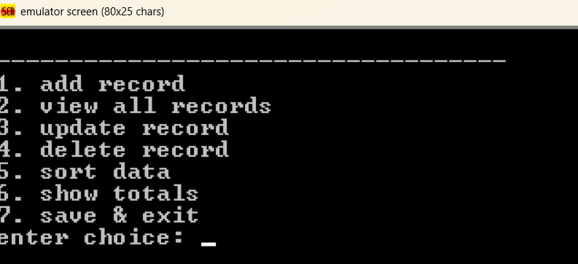
adding family data: 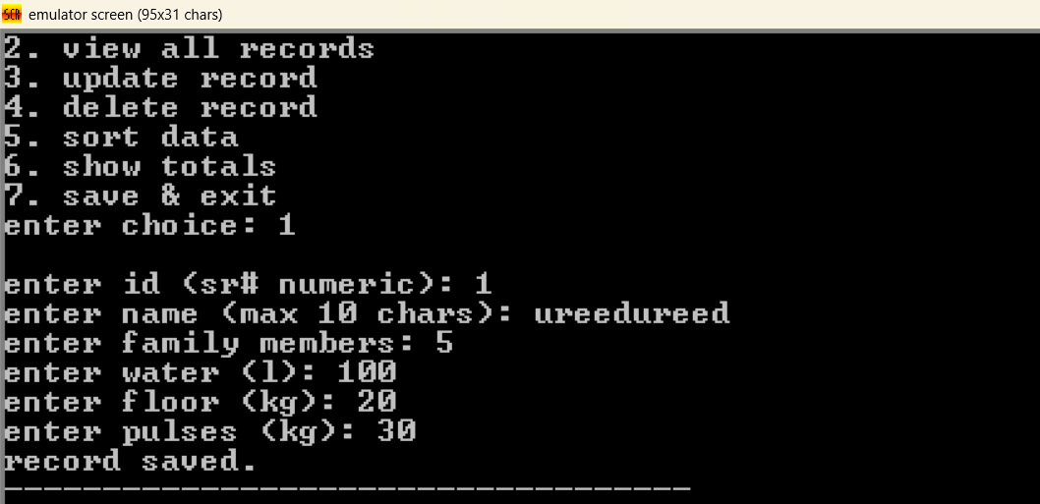
view all data table: 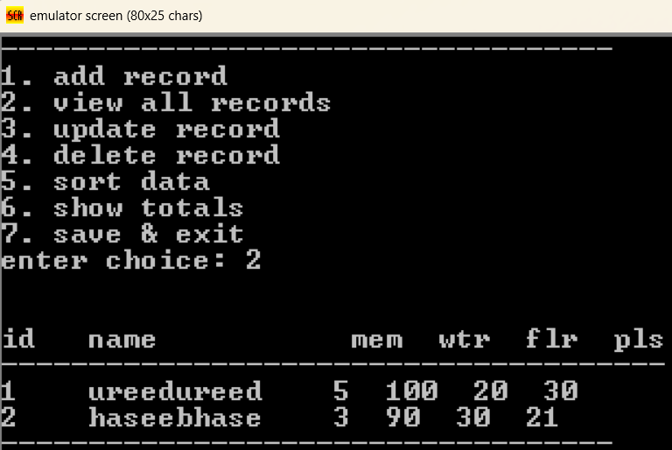
update family data: 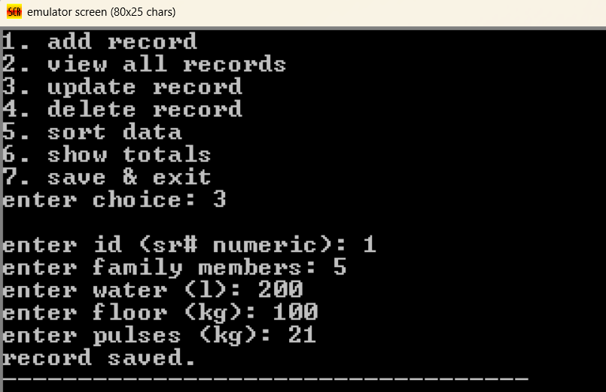
delete data: 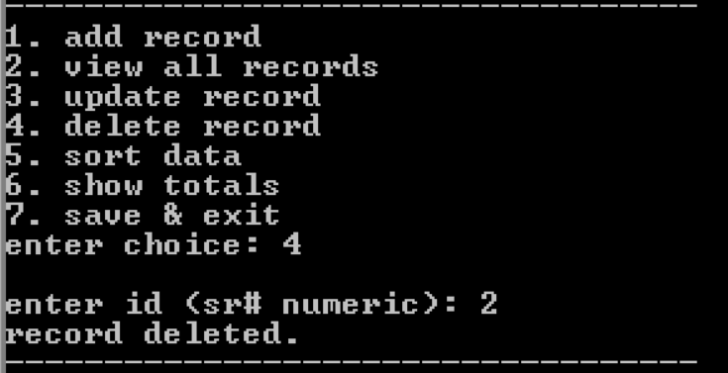
calculate totals: 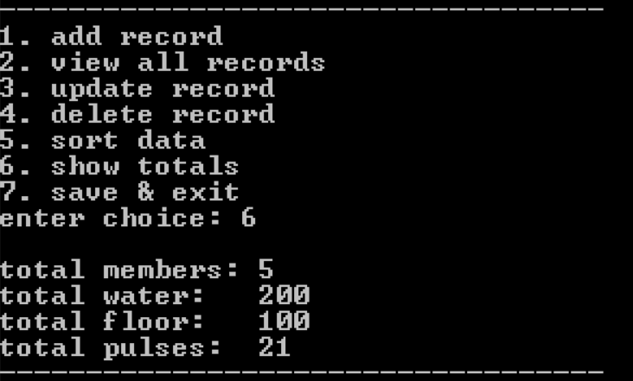
save record message: 